**Worksheet 1: Binary Numbers**

Represent each normal number by crossing out the cards you do not want to use. Then convert each set of cards into strings of 1’s and 0’s!

|  |  |  |
| --- | --- | --- |
| **Number** |  | **Binary Number** |
| 2 |  | 00010 |
| 5 |  |  |
| 3 |  |  |
| 12 |  |  |
| 19 |  |  |
| 8 |  |  |
| 15 |  |  |

**Worksheet 2: What’s the Number?**

Take turns thinking of a number between 1 and 31 (or bigger numbers if you’re feeling adventurous)! Ask your partner to convert your number into binary. Then write down the minimum number of bits needed to represent the number in binary (see example). Record your answers in the chart below. You may use the space to the right to work out the answer.

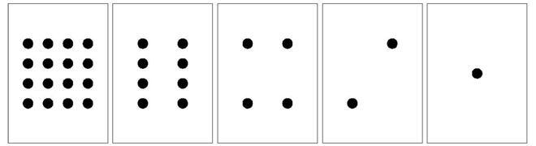

|  |  |  |
| --- | --- | --- |
| Number | 5-bit binary | Minimum Bits |
| **3** | **00011** | **2** |
| **22** | **10110** | **5** |
|  |  |  |
|  |  |  |
|  |  |  |
|  |  |  |
|  |  |  |
|  |  |  |
|  |  |  |
|  |  |  |
|  |  |  |
|  |  |  |
|  |  |  |
|  |  |  |

**Worksheet 3: Check Your Understanding**



1. What is the next number in the sequence?

00001 00010 00011 00100 ______

2. What decimal number is represented by 01011?

3. How would you write the number 20 in binary?

4. What is the largest number you can represent using five cards (i.e., five bits)?

5. What is the largest number you could represent if you had only three cards?

6. How many cards (bits) would you need to represent the number 63?